Shortcut Master

**Shortcut Master** is a simple program to locate programs in the start menu, Meaning there is not so much waiting times as the program show straight away after typing a search query. See main application window below:

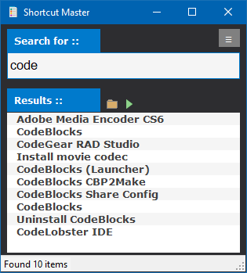

**Using the Program**

To use the program simply click in the search box and start typing part of the program you wish to find. The program will then load any items with the search teams found and will be shows in the results list box.

To load the programs you can simply double click the item. Or you can also load the item by clicking the run application icon  , you may also open the programs install location by clicking on the folder icon 

The menu button gives you the option to refresh the programs list when any operating system events have changes. There is also information about the program and exit option.

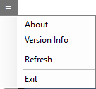

This program is released as Open Source so so you are free to modify the program as you wish. You should receive the source code along with this file.